**What is Digital Commerce as a Concept?**

In order to understand the Industries Digital Commerce solution, you need to first understand the market drivers that influenced its design and the challenges it was designed to solve. Let's begin by exploring what digital commerce is, and why it's important for telecommunications, media, and energy and utility companies.

Gartner Group defines digital commerce this way: "Digital commerce enables customers to purchase goods and services through an interactive and self-service experience. It includes the marketing activities that support these transactions, including people, processes and technologies to execute the offering of development content, analytics, promotion, pricing, customer acquisition and retention, and customer experience at all touchpoints throughout the customer buying journey."

Importantly, Gartner Group's definition suggests that true digital commerce goes beyond simply selling products online, or e-commerce. Instead, it is about the entire customer buying journey--which is far more than selling widgets online.

**Digital Commerce in Omnichannel Style**

In order to achieve this vision to support an entire customer buying journey, you need an **omnichannel**application. But what does omnichannel mean?

An omnichannel approach, brought on by the emergence of digital technology such as mobile devices and social media, uses the range of channels available to consumers and goes further to take into account customer context. The situational details of customers, such as situation details of the customer before, during, and after the transaction.

“Customers say they want the company to ‘know them’ and ‘know where they’ve been,’” says Pete Slease, principal executive advisor at Gartner. (Prioritize Omnichannel Investments to Ensure Seamless Customer Experience, Gartner, July 2019)

**Enter omnichannel digital commerce.**So, omnichannel applications provide the ability for a customer to take journeys, when, where and with whatever device they choose, and they do so within their own personal context. They want the company to appear as a seamless organization, with information shared among each of its divisions. And they want all of this at lightning speed.

**Enabling Growth with Digital Commerce**

This accelerated shift towards a customer's omnichannel journey through digital commerce, prioritizing convenience and speed, isn't easy to achieve. So why are major telecommunications, energy and utility, and media companies rushing to do this?

* Price pressures are eroding margins
* Revenue from digital channels outpaces traditional channels with higher ARPU (Average Revenue Per User) and lower SARC (Subscriber Acquisition and Retention Costs)
* Websites have the most influence on customers' brand preferences, by far
* Consumers demand the ability to do business across channels, seamlessly

**Given these factors, the greatest opportunity for growth lies in digital revenue.** Going even further, in this marketplace, digital commerce is not a nice-to-have. Instead, it's a requirement for growth.

“Maintaining the upward trajectory of ARPU and ensuring a downward trajectory for churn will require telcos to invest more in digital.”  
- Boston Consulting Group, 2018

**The Challenges of Digital Commerce**

Delivering an omnichannel customer journey through digital commerce is **hard**. To address the challenges of the marketplace, your digital solution must be a unified solution that:

**Drives Engaging Purchasing Journeys**

Today, over 80% of customer journeys begin in a digital / mobile channel. As a result, a digital solution must engage subscribers with a purchasing journey that clearly presents the latest offers and promotions.

**Delivers an Elevating Brand Experience**

Service providers must deploy digital applications that delight and amaze their prospects and subscribers with simple, easy to navigate, visual, data-rich, comprehensive, and positive interactions. The experience must reinforce the brand positioning, be available anywhere at any time, create satisfied customers and maximize opportunities to provide additional products and services that will increase the value that the service provides.

**Supports Omnichannel Sales and Service Processes**

Subscribers today expect to do business with their carriers on their own terms; at the time of their choosing, on the device or channel that is most convenient – and to be able to drop off and pick up later across channels without missing a beat. A purchasing process might be started on a mobile device, completed on the website, with a device upgrade available at a conveniently nearby retail location – transacted by appointment, with no wait.

**Supports Carrier-Grade Speeds and Reliability**

Digital and mobile application point-solutions abound in the digital commerce landscape. But they are not all developed with the scale, breadth of capability, and robustness required by telecommunications, media, and energy and utility service providers. A carrier-grade digital solution must be available to leverage across channels, easily integrate with their other back and front office solutions, and process high volumes of orders quickly, even during peak marketing events associated with new device launches and competitive promotions.

**Speed Up Time To Market with a Unified Architecture**

Siloed catalog architectures reduce agility and increase cost due to the high time-to-market (TTM) when introducing new offers, integration and maintenance costs to keep catalogs in sync, and the duplication of data.  
  
A unified commerce architecture with CPQ, order management, and digital commerce capabilities allows you to get up and running with new products and offers faster than ever.

**The Industries Digital Commerce Solution**

**Industries Digital Commerce**(Digital Commerce) was designed to solve the challenges described above. Digital Commerce addresses both service providers and subscriber needs and is built on an integrated omnichannel platform that enables design, order capture, order management, and customer management scenarios across all channels and devices. This enables you to more quickly launch new offers, and provides users a seamless experience, from purchase to delivery to support.

**Industries Digital Commerce**is a cloud-based solution that enables high-volume browsing and product configuration on digital self-service channels.

Additionally, it provides a digital commerce application tier that includes intelligent caching for advanced order-capture and guided-selling customer journeys--to get the right products and services to the right customers at scale and speed.

Finally, it enables sales and service processes in all the digital channels a service provider requires (websites, portals, mobile applications, retail locations, and more). Industries omnichannel design supports direct customer channels or partner channels through a Salesforce Community, a content management system (CMS) front end, or its APIs. The digital DNA of Digital Commerce enables this flexibility and the reusable component design that delivers a positive return on a customer's Industries investment.  
  
You're probably wondering how Industries Digital Commerce can accomplish so much. Let's take a look at each technical component layer of the product:

Digital Commerce Components

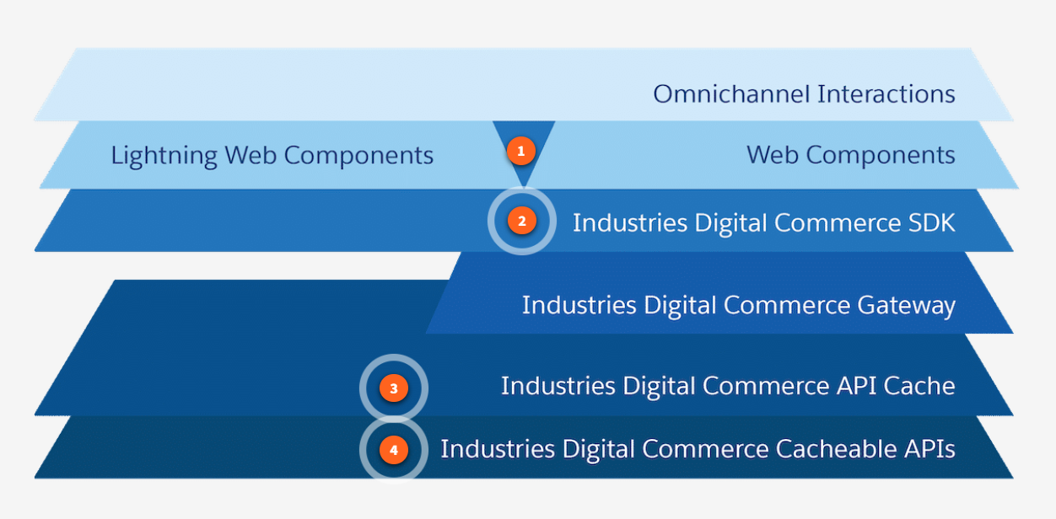

1. **Industries Sample Web Components** illustrate how to call the Industries Digital Commerce APIs through the Industries Digital Commerce SDK.  
     
   We offer two types, industry-standard **web components**and **Lightning web components**. Web components can build UI outside the Salesforce Core platform. In contrast, Lightning web components are leveraged when building the UI on Salesforce Core, such as when using Experience Cloud (formally known as Communities).  
     
   However, the introduction of flex cards has made it much more pliable to call the Industries Digital Commerce APIs. They are built on Lightning web components and can be used off-platform.
2. **Industries Digital Commerce SDK**is a pure JavaScript library that abstracts and simplifies the use of Digital Commerce APIs. The SDK improves usability and reduces the effort to develop compelling user interfaces by hiding complex API semantics inside the SDK interface.
3. **Industries Digital API Caching** pre-generates anticipated high-volume API calls. More specifically, We only inorganically create the cache for [GetOffers](https://docs.vlocity.com/en/Get-Offers-By-Catalog-API.html" \t "_blank) and [GetOfferDetails](https://docs.vlocity.com/en/Get-Offer-Details-API.html" \t "_blank) for anonymous users. We organically create the cache for all Basket operations and GetOffers/GetOfferDetails for Identified User Context.  
     
   The Industries Digital Commerce Gateway is built as part of an Amazon Web Services offering.  Its purpose is to execute only our Cacheable APIs and store our Cacheable APIs’ responses to address additional scalability needs. It is not customizable by Industries customers or services teams.
4. **Industries Digital Commerce APIs**extends the Shared Catalog to digital channels, allowing product browsing, selection, and configuration for anonymous and logged-in users.

**Adaptive Scalability**

So what are the benefits of using Industries Digital Commerce? To start, very large communications, media, and energy and utilities companies may require additional adaptive scalability for peak traffic events, such as iPhone roll-out or pay-per-view specials.

The **Digital Commerce Gateway** is an elastically scalable commerce engine that addresses this need by offloading Industries CPQ processing from the Salesforce platform using an API Gateway and a cache store. The architecture of our API caching solution is platform-agnostic. The Digital Commerce Tier is certified on Amazon Web Services and operated by Salesforce.

Extending the Shared Catalog to Digital Channels

Underlying Digital Commerce is the**Shared Catalog**. The shared catalog is Industries' central repository, the single source of truth for commercial and technical product information that supports all channels to market, sell, and drive fulfillment.

This is the same shared catalog used in EPC, Industries CPQ, Contract Lifecycle Management, and Industries Order Management. Now it's extended for Digital Commerce, which allows you to reuse your existing products, promotions, pricing, rules, order decompositions, and orchestrations. This significantly increases agility and decreases development time in deploying your digital commerce solution.

Benefits of Digital Commerce

Digital Commerce solution brings many benefits to telecommunications, media, and energy and utilities companies.

* **Reduce Time to Market with Catalog-Driven e-Commerce**:  Eliminate product silos, lower integration costs & complexity, and significantly reduce launch time for new offers through a centralized digital e-commerce catalog.
* **Improve Response Times with Intelligent Caching:**Accelerate website responsiveness during peak events through digital API caching for anticipated high volume API calls.
* **Manage Peak Traffic & Elastic Scaling:**Offload static calls from constrained services. Pre-cache high-volume API calls on the AWS or Salesforce platform.

**The Foundation of Industries Digital Commerce**

The foundation of any digital commerce experience is the product inventory, and to retrieve the correct products for users, you can count on Industries CPQ. Industries CPQ provides you with a suite of CPQ Services based on modern, enterprise-scale Digital Commerce APIs. Industries Digital Commerce cacheable APIs serve as the standard method for on and off-platform Digital Commerce apps to retrieve products and post orders.

One of the benefits of Digital Commerce APIs is that they provide a layer of abstraction between back-end developers and Salesforce catalog admins who configure and customize the underlying CPQ logic. Industries CPQ defines business logic and rules, which are respected by Digital Commerce API calls, so you can be assured that customers are seeing the correct products and pricing.

The Industries Digital Commerce front-end (web components and SDK) and back-end (caching and APIs) fetch products, pricing, configuration, rules, and more via Industries CPQ's interfaces and the Shared Catalog. Catalog Admins can continue to work on-platform with Industries CPQ whereas developers may be working on and off-platform with the Digital Commerce architecture.

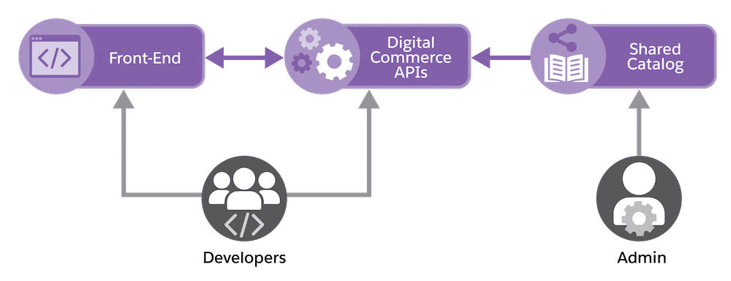

**Industries CPQ Services**

When you start to examine the underlying mechanisms that power Digital Commerce, it's always important to visualize your commerce site's bigger picture. It will require various services to complete standard tasks like selecting phones, promotional pricing, add-on products, etc. You can use the Digital Commerce APIs to develop commerce services such as:

* Product Selection
* Attribute-Based Configuration
* Attribute-Based Pricing
* Self-service and Mobile Ordering

**Industries CPQ Business Logic and Rules**

Salesforce catalog admins and developers have to think about their inventory and their target audiences when modifying prices, customer eligibility rules, promotions, and more. This is defined as business logic, and can be summarized by a few questions:

* **What products** are available for purchase?
* **How** should the products be configured?
* **Which customers** can buy each product?
* **What price** do they pay?

Business logic is implemented using rules and various product settings in the Shared Catalog. This is where product and promotion data is maintained and serves as the source of truth for commerce applications. Furthermore, Digital Commerce APIs will **only** access products and promotions in the sales catalog, which are created independently of the Shared Catalog, but utilize the same pricing and eligibility rules.  
  
To access that sales catalog product and pricing data in your app, you must call the data using a CPQ interface, which in our case, is by using Digital Commerce APIs. A CPQ interface guarantees that the correct logic is applied, making sure that every order is a perfect order, whether the transaction happens on-platform or off-platform.

In this example, the GetOffersByCatalog Digital Commerce API is requesting a sales catalog for a logged in user. The Shared Catalog and its rules that apply to that sales catalog are run by the ContextRuleService and ProductAvailabilityOpenInterface CPQ interfaces. The appropriately priced and available products of that sales catalog are returned in the response of the GetOffersByCatalog API, for the rest of the Digital Commerce architecture to process.

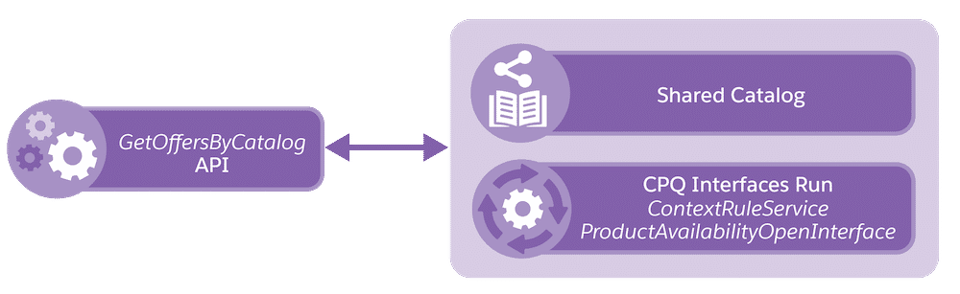

Different Digital Commerce APIs call different CPQ interfaces, such as the GetOffersByCatalog (retrieving sales catalog products) Digital Commerce API running the ContextRuleService and ProductAvailabilityOpenInterface CPQ interfaces. In this case, these two interfaces enforce context rules and product availability in this API's response. Similarly, other Digital Commerce APIs run interfaces such as ProductValidationInterface, PricingInterface, and TightestMatch.

**The Benefits of Industries Digital Commerce Cacheable APIs**

Industries Digital Commerce cacheable APIs are standard RESTful Web APIs and utilize GET, PUT, and POST HTTP requests. They're designed to enable client applications such as consumer-facing web and mobile apps to shop for products and services. Digital Commerce APIs are built on the Force.com platform using Apex REST and retain the reliable and fine-grained security that you expect from Salesforce.

Digital Commerce APIs are optimized for consumer shopping use cases, where the user may be **anonymous** until well into the check-out process. These APIs are also optimized to enable **caching** of API responses to provide additional **performance** and **scalability**. These APIs are optimized for lower bandwidth connections between the client app and the server by minimizing the metadata returned in the response. Finally, Digital Commerce APIs are utilized in the Digital Commerce SDK, web components, and Lightning web components, so you can expect consistent behavior no matter which tools you use to develop your app.

**Comparing Cart-Based and Digital Commerce APIs**

Before we dive into Digital Commerce Application Architecture, we should take a moment to address the differences between Cart-based APIs and Digital Commerce APIs. If you've taken other training or developed on-platform guided selling or self-serve experiences using the Cart or OmniScript Designer, you may have utilized the CPQ interface CpqAppHandler using Cart-based API methods. CpqAppHandler is a global Apex class that includes several API methods to perform CPQ functionality.  
  
Cart-based APIs allow you to do everything from adding items to a cart, adding promotions, apply adjustments, and more. Fundamentally, Cart-based APIs require a **Cart Id** and either an **Opportunity Id**, **Quote Id**, or **Order** **Id** as a first step. Orders and Opportunities require an **Account Id**while Quotes require an **Opportunity Id** as additional required inputs. Generally speaking, Cart-based APIs are optimized for highly interactive cart operations performed by contact center agents and sales reps, using an editor such as the Cart.  
  
Digital Commerce APIs do not require a cart to be created. The first step for Digital Commerce APIs is to get offers/products using a **catalog code** as an input. This allows for **anonymous** users to browse sales catalogs and configure offers without needing to register an account. Another feature of Digital Commerce APIs also allows for the **caching** of API responses, to enhance performance, whether it's on-platform or off-platform. Digital Commerce APIs are optimized for consumer-facing apps that require fast performance and anonymous browsing.

**Digital Commerce APIs Overview**

Digital Commerce APIs are the foundational layer of the Digital Commerce tech stack, and they directly interact with Industries CPQ, Enterprise Product Catalog, and Salesforce. Fundamentally, every API call directly retrieves data from Salesforce. The added benefit of the CPQ interface ensures that the current pricing and attributes are relayed in the API response. The API call can be appended with contexts such as eligibility rules. This means you can make API calls that will retrieve products that are only valid for a certain user shape. If you have the **Digital Commerce Gateway**, the data will be retrieved from AWS.



Industries Digital API Caching and Digital Commerce Gateway make up the bottom two API layers of the tech stack, which form the rest of what we informally call the Digital Commerce backend.

One of the big benefits of Digital Commerce APIs is that their responses can be cached for fast performance. Why caching? The characteristics of digital commerce volumes provide optimization opportunities. A large proportion of interactions are anonymous or near anonymous. The early-stage anonymous traffic lends itself to caching as many users receive the same responses. Therefore, intelligent caching strategies coupled with a cacheable set of APIs are critical in any enterprise-scale digital commerce solution.

As shown in the image below, product and pricing metadata stored in the Product Catalog constitutes the seed data to the engine which creates priced offers that will be cached inside Salesforce. Caching mechanisms will store API responses inside Salesforce (Cache Generator). These API responses will then be an available resource to the set of new APIs, resulting in high-performance response times (API Response Cache).

The Digital Commerce Gateway is an optional component of the architecture that will enable customers to store the cached API responses outside of Salesforce. This gateway is especially relevant for large organizations that receive a high volume of traffic.

When requests are made by customers, the new APIs can first refer to the API response cache which will be located on-platform (in Salesforce) or located off-platform in the Digital Commerce Gateway. The Digital Commerce Gateway is certified on Amazon Web Services and operated by Salesforce.

**Using Sales Catalogs in Digital Commerce**

**Sales catalogs** are used to organize groups of selected products and promotions from the Shared Catalog into digital commerce offerings. Sales catalogs are ideal for digital commerce sites because they can be curated for specific product marketing strategies.

Sales catalogs are comprised of **Catalog Product Relationships** that define the products and promotions that are included in the catalog.

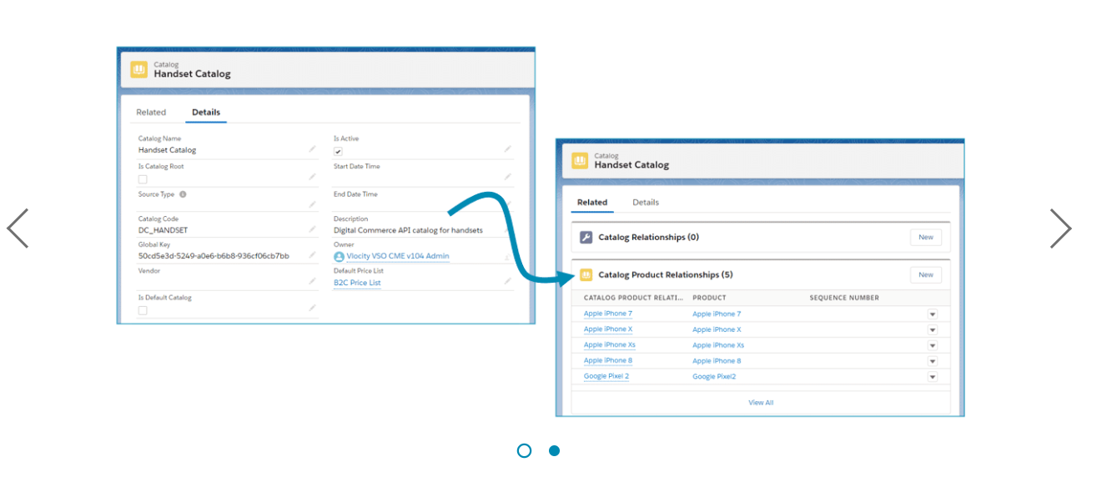

# How to Build Sales Catalogs for Digital Commerce

**Creating a Sales Catalog**

To create a new sales catalog, go to the Catalog tab, click New, and set the following fields:

* **Catalog Name:**Required. But the catalog name is not returned by any of the digital commerce queries, and will not display at run-time.
* **Catalog Code:** Must be unique and contain no spaces. You will use this code to request the catalog's products and promotions programmatically.
* **Default Price List**: The price list used for the products and promotions contained in the sales catalog. It's important to ensure that each product or promotion in the sales catalog is listed in the specified price list.
* **Is Active**: This flag must be checked.

When using sales catalogs in digital commerce, the catalog hierarchy (Catalog Root) is not used, nor are the Start Date or End Date times.

**Creating a Catalog Product Relationship**

Once you've created your sales catalog, create **Catalog Product Relationships** to define which products or promotions should be included in the catalog. Be sure to create separate catalog product relationships for each product or promotion.

* **Catalog Product Relationship Name:**Required. But the catalog product relationship name is not returned by any of the digital commerce queries, and thus, will not display at run-time.
* **Catalog:** This will be set for you.
* **Product**: Ensure that this product is on the price list specified in the sales catalog.

-**OR-**

* **Promotion**: Ensure that this promotion is on the price list specified in the sales catalog.
* **Is Active**: This flag must be checked.

The Effective Date and End Date fields are not used. Sequence can be used in some cases.

The Digital Commerce solution has been designed to help you achieve a new level of speed and agility in your journey to digital transformation. However, the path to successful digital transformation is more than just our tools. Equally important is the project methodology you use and the team who will deliver it. Let's dig into the skills and team you may want to put together.

**What Skills Do We Need?**

With Digital Commerce, you are creating a digital experience for your customers, and you will need different skill sets and project roles than are required to implement a traditional Salesforce project. Executive strategy and vision are essential as well as digital implementation skills.

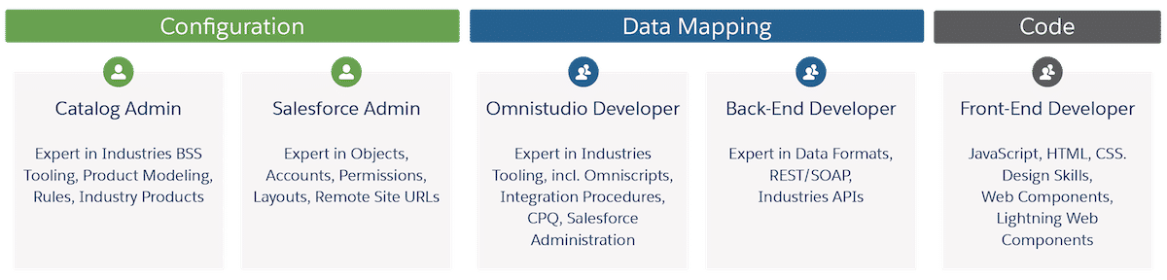

**CATALOG ADMIN**  
This role is a certified Industries CPQ Developer and manages the Shared Catalog, which includes products, pricing, and rules.  
  
**SALESFORCE ADMIN**  
Since the Digital Commerce solution is built on the Salesforce platform, this role is responsible for standard Salesforce administration.  
  
**OMNISTUDIO DEVELOPER**This role is a certified OmniStudio Developer and represents the "art of the possible" with Industries tooling such as OmniScripts, Integration Procedures, and DataRaptors.  
  
**BACK-END DEVELOPER**  
The project team must include back-end developers who are skilled in service-oriented architectures and are committed to learning Industries' Digital Commerce APIs and caching architecture.  
  
**FRONT-END DEVELOPER**  
With Digital Commerce, creating an easy-to-use, consumer-grade web experience is an absolute requirement. While Industries provides compelling web experiences in the sample reference application, you must adapt those designs to your brand and optimize the experience for your customers. This requires the engagement of user experience designers -- especially during the prototype phase -- as well as web developers (HTML, CSS, JavaScript).

**Industries' Digital Transformation Methodology**

Industries' digital transformation methodology begins with developing the future state vision and emphasizes working software throughout the project--first with a sample reference application and then with a visionary prototype, which is developed into the final deployment. Accelerating the time to working software maximizes the opportunity for user feedback and refinement and also maximizes the opportunity for a transformative result.

Industries' methodology is also designed to front-load foundation technical design decisions and drive alignment with a transformational vision. The methodology has five key phases:

1. Vision

The vision phase establishes the functional scope of the application and the transformational goals that the project is intended to achieve. Clarifying, documenting, and communicating the scope and vision will guide prioritization throughout the future phases and provide a measuring stick for the project’s ultimate success. Know thyself—your requirements will drive the team you build and the technology you use. Ask yourself, how many overall orders do you expect per hour? How many peak orders? Abandoned orders? Questions like this will determine the scale of the project and the number of workstreams. The key is to combine savvy market understanding with the 'art of the possible' with technology.

1. Model

Use Digital Commerce reference app as the starting point

* Contact Industries Support
* Implement simple pricing and rules
* Design and implement single Catalog
* E2E user experience and order management
* Plan authentication + security architecture (off-platform)

Conduct Expert Services Design Review

* Contact Industries Expert Services
  + Industries recommends beginning the product and catalog modeling at the very beginning of the project since it is at the heart of the digital commerce flow. Use the Digital Commerce reference app as the starting point, and request an Industries Expert Services Design Review to ensure best practices are followed.

1. Prototype

Test and Iterate User Experience:

* Web components / Lightning web components
* Mock authentication/login
* MVP product model
* Develop styling / branding
* Set Up DevOps
  + See Industries DX on Industries Support Center

The prototype phase is critical in ensuring the transformation objectives of the project. Typically short, running two to six weeks, an end-to-end prototype enables identifying the core design and any technical issues and gaps before the build commences. Doing so early in the process increases the opportunity for elegant solutions. The resulting prototype becomes the basis for the final application.

1. Build

* Catalogs, products and rules
* Implement styling theming/CSS
* Implement login & checkout process / integrate with authentication mechanism
* OmniScript (if needed)
* Digital Commerce Tier (if needed, with Vlocity Operations)

Maximizing the speed and productivity of the build phase requires staffing and/or enabling the team with the correct skills, based on the scoping and any items identified from prototyping. DevOps processes should be established at the on-set of the build phase to ensure efficient development. Concrete completion criteria should be established for each project asset to ensure accurate progress tracking.

1. Deploy

* Portal / App Deployments
* User Management
* Data Migration
* Reporting & Dashboards

Crafting the right deployment strategy is critical to achieving rapid user feedback, and then being able to iterate on the solution. Some of Industries' most successful projects opted to deploy a limited set of products and/or jurisdictions in a compressed timeframe – often just 8-16 weeks - and then refine the solution. Industries DX tools, along with Salesforce DX, should be used to automate the deployment pipeline and thus minimize the effort of iterations.

**The Prototype Team**

Prior to the start of the Prototyping phase, Industries**strongly recommends**engaging with Expert Services to conduct a Digital Commerce design review of the output of the Model phase. A design review ensures that your digital commerce application will be configured and built following best practices, which will help you more rapidly deliver and deploy your solution--and avoid costly mistakes. Contact your account team or Industries Support to schedule your design review.

**Grow the Application from the Prototype**Prototype Methods

* Digital Commerce Reference App
* Sample Web Components & Controls
* Mock Endpoints / Authentication

Prototype Output

* Catalog & Product Model Structure
* Pricing Structure
* Working Web Application
* UX Design

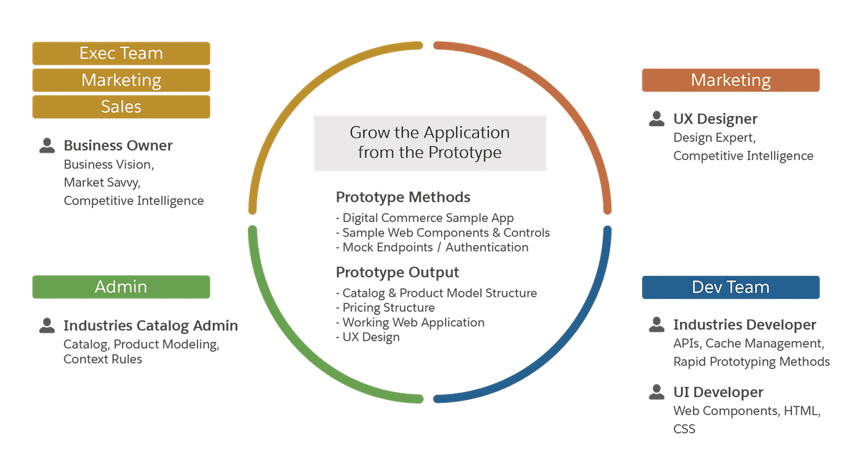

During the Prototype phase, five key roles are suggested, and each role might have more than one person. Engaging a small but senior team is recommended. Delegating user story creation to less-experienced team members or external consultants often results in simply rebuilding an old system's capabilities in new technology. Instead, use a senior and visionary team--along with design, product, and technology expertise--to dramatically increase the probability of a transformative result.

# Industries Digital Commerce Design Patterns

**Design Patterns for Digital Commerce**

The Digital Commerce solution was developed to allow you to create amazing omnichannel customer journeys. As with any great technology, it's important to use it wisely. Industries recommend these design patterns for use with the Digital Commerce solution:

* Anonymous catalog browsing on public websites
* Self-service order processes on communities or public websites
* High-volume order processes for peak events, such as Pay-Per-View (PPV)

Digital Commerce allows you to achieve a great user experience by providing:

* A "friendly" user interface that is easily branded
* High-performance response times and page draws
* Simplified product configuration and checkout

**Digital Inspiration**

Next, we'll provide UI images of the Digital Commerce reference app that illustrate various features of the Digital Commerce solution.

Digital Commerce provides the ability to retrieve products and promotions that are modeled within the Shared Catalog. The specified catalog code identifies the catalog that contains offers (products and promotions). You can optionally specify a page size to limit the number of results returned.

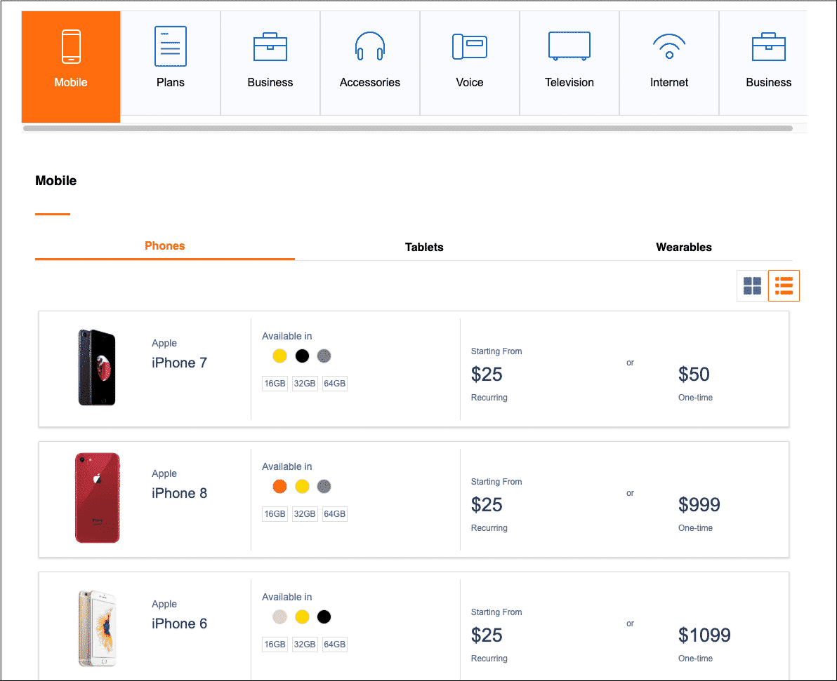

In addition, the solution allows you to retrieve offer details that are modeled within the Shared Catalog. Within the context of a catalog, the response returns product and promotional-level details, including attribute configurations and pricing information.

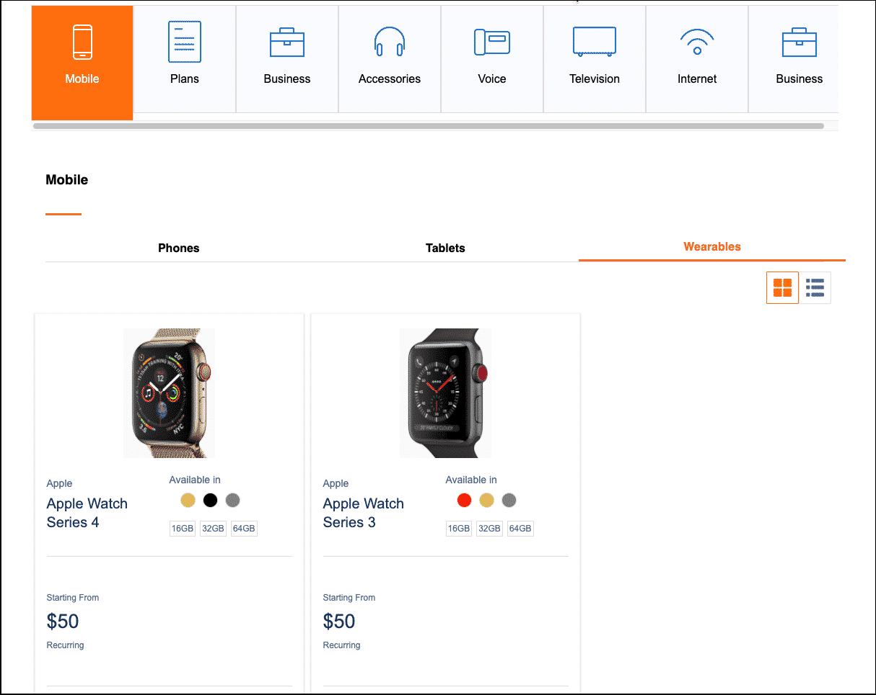

You can also promote featured products and promotions that are modeled within the Shared Catalog. The API is a variation of Get Offers by Catalog. The specified catalog code in the request identifies the catalog that contains offers (both products and promotions) that are identified as best or featured offers.

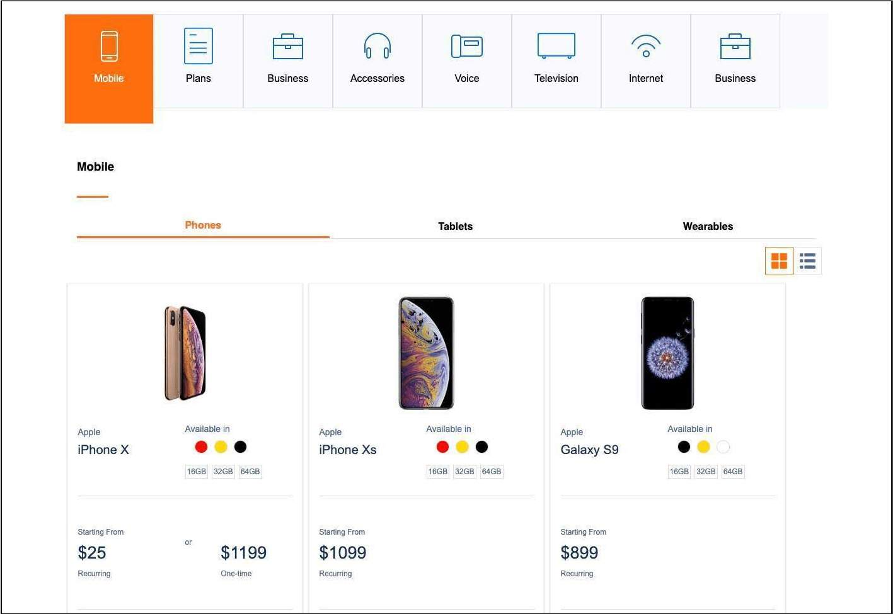

Digital Commerce also allows offer configuration before adding it to the cart using cacheable attribute-based pricing.

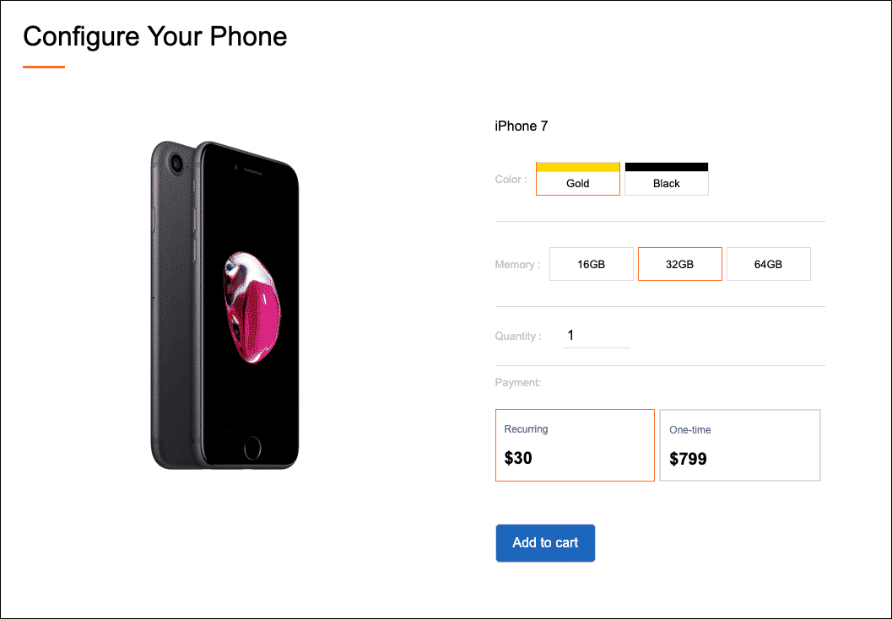

Add products to your cart--no card id or account id is required!

